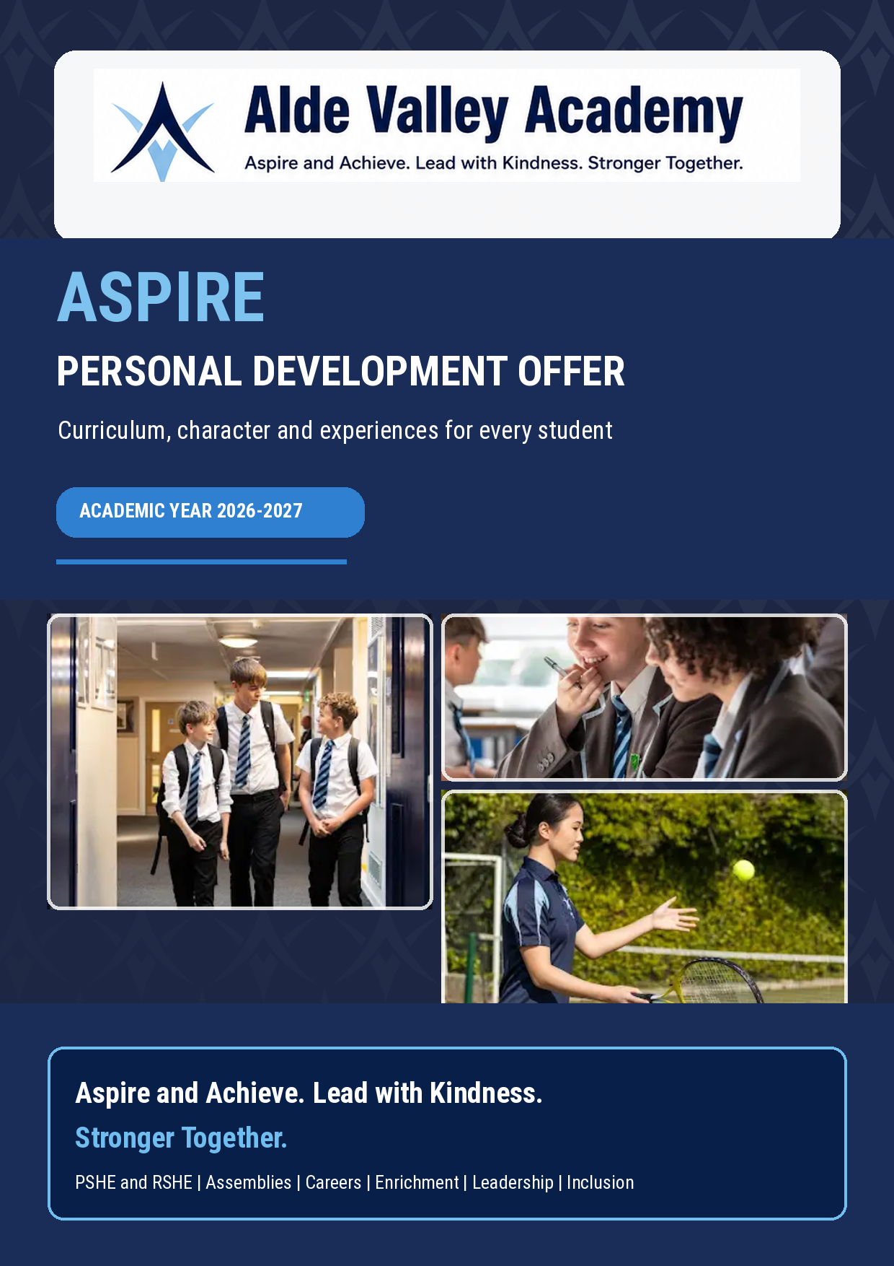

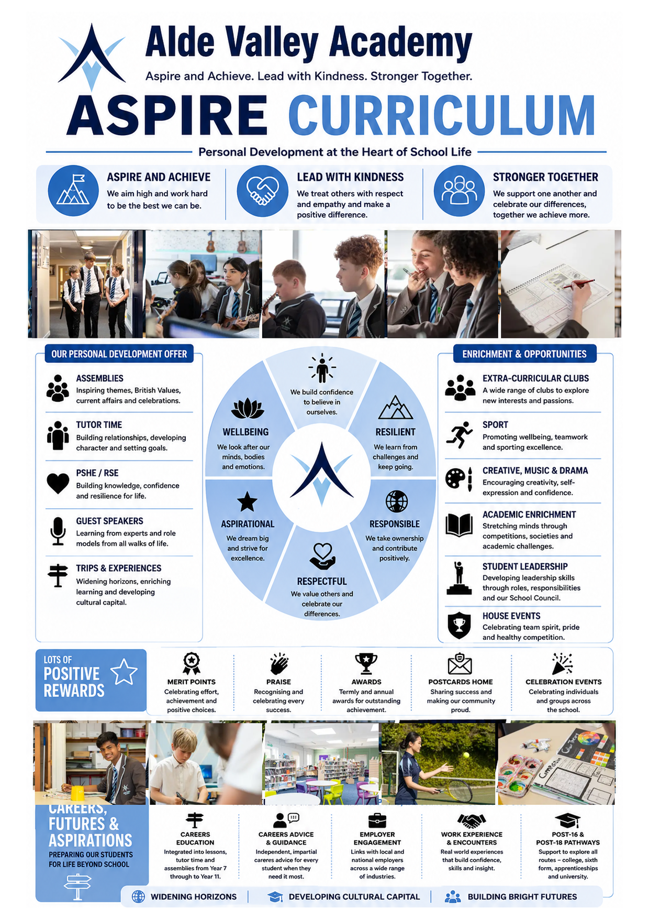

OUR WHOLE-SCHOOL PERSONAL DEVELOPMENT OFFER  ASPIRE is the golden thread through school life | 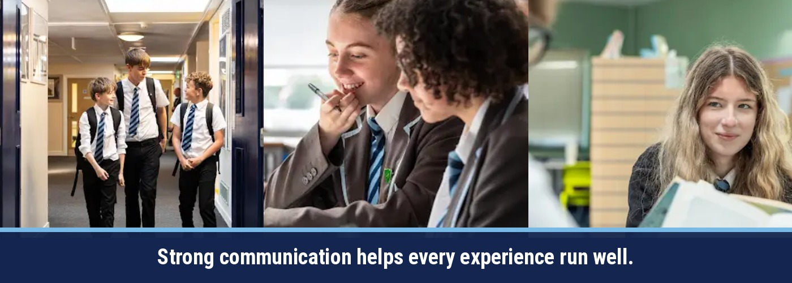

Students do not experience PSHE, assemblies, careers and enrichment as separate programmes. Each strand deliberately reinforces the same values, knowledge and habits so students can understand, practise and apply what they learn.

PSHE & STATUTORY RSHE  Healthy, safe and respectful decisions. | ASSEMBLIES & TUTOR/PLANNER  Shared language, current issues and reflection. | CAREERS & FUTURE PATHWAYS  Ambition, employability, encounters and guidance.
CLUBS, SPORT & CREATIVITY  Participation, wellbeing, talent and belonging. | ASPIRE CURRICULUM  Aspire and Achieve  Lead with Kindness  Stronger Together  Confident • Resilient • Responsible  Respectful • Aspirational • Well | TRIPS & CURRICULUM EXPERIENCES  Cultural capital, independence and real-world learning.
LEADERSHIP, VOICE & REWARDS  Contribution, responsibility and recognition. | SMSC & BRITISH VALUES  Citizenship, rights, respect and modern Britain. | SEND, SAFEGUARDING & INCLUSION  Access, adaptation, protection and support.

ONE LANGUAGE • ONE JOURNEY • MANY OPPORTUNITIES

INTENT, IMPLEMENTATION AND IMPACT  A planned and evaluated approach to personal development | 

Our purpose is to develop pupils' character, resilience, wellbeing, citizenship, aspiration and preparation for life in modern Britain. Personal development is everyone's responsibility and is delivered through a coherent whole-school curriculum.

INTENT  • Build confidence, character and a secure sense of belonging.  • Equip students to be healthy, safe and respectful.  • Develop knowledge of rights, responsibilities and modern Britain.  • Raise aspirations and prepare every student for future pathways. | IMPLEMENTATION  • Sequenced PSHE and statutory RSHE from Years 7-11.  • Assemblies, tutor time and planner activities reinforce learning.  • Careers, enrichment, leadership and curriculum experiences provide application.  • Adaptive teaching, safeguarding and specialist support secure access. | IMPACT  • Students make informed, safe and responsible choices.  • Students communicate respectfully and contribute positively.  • Students understand pathways and move confidently to their next stage.  • Participation, pupil voice and destination information show growing readiness.

THE ASPIRE THROUGHLINE
ASPIRE & ACHIEVE  Goals • resilience • curiosity • decision making • careers and ambition | LEAD WITH KINDNESS  Respectful relationships • empathy • equality • inclusion • wellbeing | STRONGER TOGETHER  Belonging • citizenship • teamwork • student voice • community contribution

The outcome: responsible, respectful and aspirational young people who are ready to thrive, contribute and progress.

THE FIVE-YEAR PERSONAL DEVELOPMENT JOURNEY  Knowledge and experience grow in depth from Year 7 to Year 11 | 

The spiral model revisits key themes with increasing maturity. Taught learning is reinforced through assemblies, careers, enrichment, leadership, safeguarding and real-life experiences.

YEAR & THEME | PSHE / RSHE CURRICULUM | CAREERS & WIDER EXPERIENCE | ASPIRE DEVELOPMENT
YEAR 7  BELONGING | Transition and belonging; health and puberty; healthy relationships; identity and diversity; safety and risk; careers and aspirations. | Unifrog introduction, clubs, subject enrichment, trips and participation in academy life. | Settle, build friendships, feel safe and grow in confidence.
YEAR 8  RESPONSIBILITY | Mental health and wellbeing; online safety; relationships and consent; substances; democracy and citizenship; employability. | College awareness, skills language, competitions, creative and sporting participation. | Take responsibility, understand consequences and contribute to the community.
YEAR 9  INDEPENDENCE | Media and influence; drugs, crime and exploitation; sexual health; equality; resilience; GCSE pathways and futures. | Options guidance, Suffolk New College, Duke of Edinburgh and emerging leadership. | Make informed choices, manage influence and take on new challenges.
YEAR 10  SAFETY & RISK | Healthy relationships and abuse prevention; sexual health; mental wellbeing; financial wellbeing and employability. | Work experience, employer encounters, mock interviews, curriculum fieldwork and public performance. | Apply learning, manage risk and build employability.
YEAR 11  PREPARATION FOR ADULTHOOD | Relationships and the law; harmful practices; online harms and AI; adult health; independent living; post-16 transition. | Applications, careers fair, apprenticeships, college and university information, personal guidance. | Move confidently to the next stage with independence and purpose.

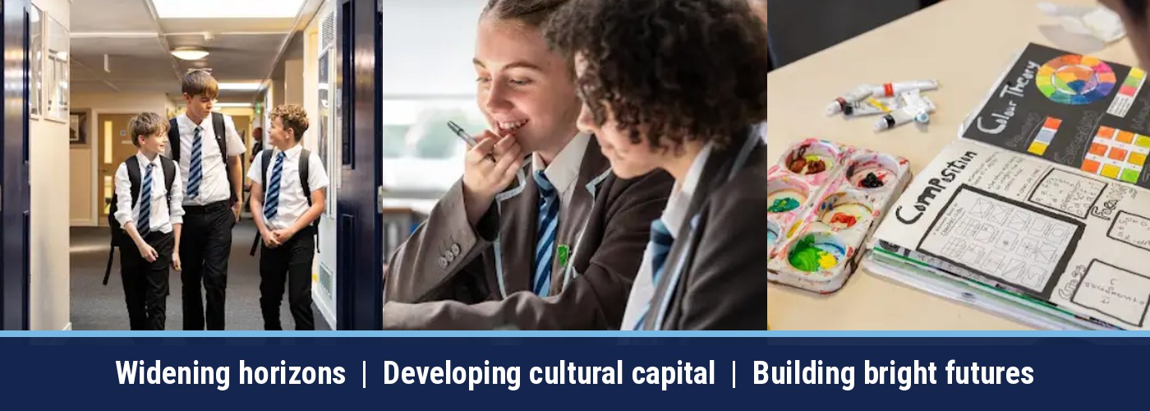

PSHE, RSHE AND THE SPIRAL CURRICULUM  Planned statutory learning that becomes more sophisticated each year | 

PSHE and statutory RSHE provide the taught backbone of the offer. Learning is delivered through timetabled lessons, tutor and planner activities and KS4 drop-down provision, with external specialists where appropriate. Safeguarding, assessment and signposting are built into delivery.

YEAR | SPIRAL CURRICULUM SEQUENCE
YEAR 7 | Transition & Belonging • Health & Puberty • Healthy Relationships • Identity & Diversity • Safety & Risk • Careers & Aspirations
YEAR 8 | Mental Health & Wellbeing • Online Safety & Digital Life • Relationships & Consent • Substance Use & Risk • Democracy & Citizenship • Careers & Employability
YEAR 9 | Media, Identity & Influence • Drugs, Crime & Exploitation • RSE & Sexual Health • Equality & Society • Mental Health & Resilience • GCSE Pathways & Futures
YEAR 10 | Healthy Relationships & Abuse Prevention • Sexual Health & Mental Wellbeing • Financial Wellbeing & Employability
YEAR 11 | Relationships & the Law • Harmful Practices • Online Harms & AI • Adult Health & Wellbeing • Independent Living • Post-16 Transition

STATUTORY COVERAGE AND SAFE DELIVERY
HEALTH & WELLBEING  • Mental wellbeing and resilience  • Healthy lifestyles, puberty and sexual health  • Substance misuse, safety and support services | RELATIONSHIPS & RSHE  • Friendships, communication and consent  • Healthy and unhealthy relationships  • Online harms, exploitation and harmful practices | WIDER WORLD & FUTURES  • Citizenship, democracy and equality  • Financial education and independent living  • Careers, employability and post-16 transition

DELIVERY PRINCIPLES: ground rules, anonymous questions, active learning, clear signposting, adaptive resources, assessment and prompt follow-up of misconceptions or safeguarding concerns.

ASSEMBLIES, TUTOR TIME AND THE PLANNER  A shared weekly language that reinforces the taught curriculum | 

Assemblies are sequenced against the school planner, tutor activities and the ASPIRE curriculum. A common template uses a big question so students encounter the same core message, vocabulary and values through different parts of school life.

WEEKLY ASSEMBLY PATTERN
MONDAY  YEAR 11 | TUESDAY  YEAR 10 | WEDNESDAY  YEAR 9 | THURSDAY  YEAR 8 | FRIDAY  YEAR 7

A YEAR OF SHARED THEMES
AUTUMN  Belonging and motivation; democracy; mental health; equality and diversity; poverty; money and careers; character; war and remembrance; masculinity; consent; human rights and migration. | SPRING  Goals and decision making; healthy eating; the Holocaust; science and curiosity; careers; language and books; women's rights; anti-racism; personal growth and hope. | SUMMER  Expectations and behaviour; neurodiversity; stress; gender and equality; knife crime and safety; climate change; oceans; refugees; online safety; disability; careers and friendship.

HOW THE STRANDS CONNECT
ASSEMBLY THEME | PSHE / RSHE LINK | BRITISH VALUE | ASPIRE BIG IDEA
Mental health | Health & wellbeing | Individual liberty | Resilience
Consent | Healthy relationships | Mutual respect | Responsibility
Careers | Living in the wider world | Individual liberty | Aspiration
Neurodiversity | SEND and inclusion | Mutual respect | Belonging
Climate change | Sustainability | Democracy | Stewardship

1 BIG QUESTION  Assembly introduces | 2 FOLLOW-UP  Tutor and planner revisit | 3 DEEPEN  PSHE/RSHE teaches | 4 APPLY  Students act and reflect

CAREERS, LEADERSHIP AND BRIGHT FUTURES  From early curiosity to confident post-16 transition | 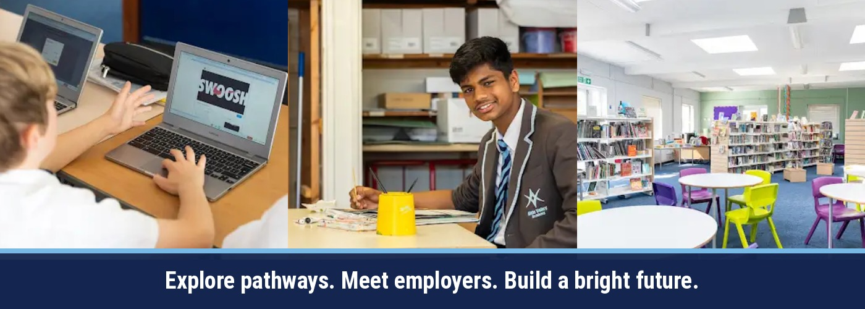

Careers education is embedded from Year 7 to Year 11 through lessons, tutor time, Unifrog, assemblies, employer encounters, curriculum links, work experience and personal guidance. Leadership gives students regular opportunities to practise the skills employers and communities value.

YEARS 7-8  EXPLORE  Interests, strengths, careers language and awareness of pathways. | YEAR 9  DISCOVER  Options, college encounters, leadership and informed choices. | YEAR 10  EXPERIENCE  Employers, mock interviews, workplace preparation and work experience. | YEAR 11  PROGRESS  Applications, FE/HE and apprenticeships, personal guidance and destinations.

GATSBY BENCHMARKS IN PRACTICE
1. Stable careers programme  Embedded curriculum, careers plan and Unifrog. | 2. Labour market information  Pathways, sector information and future opportunities.
3. Individual needs  Goal setting, pathway planning and targeted support. | 4. Linking curriculum to careers  Subject skills, employability and curriculum encounters.
5. Encounters with employers  Speakers, events, projects and local employer links. | 6. Experiences of workplaces  Preparation and Year 10 work experience.
7. FE and HE encounters  College, sixth form, apprenticeship and university guidance. | 8. Personal guidance  Careers interviews and individual support.

LEADERSHIP OPPORTUNITIES  • Subject Ambassadors and event leaders  • Sports Leaders and team responsibilities  • Peer mentoring, School Council and student voice  • House events, volunteering and Duke of Edinburgh | SKILLS STUDENTS PRACTISE  • Communication and teamwork  • Reliability, organisation and problem solving  • Leadership, reflection and decision making  • Confidence, aspiration and professional behaviour

SMSC, BRITISH VALUES, INCLUSION AND SUPPORT  Stronger Together means every student can participate and progress | 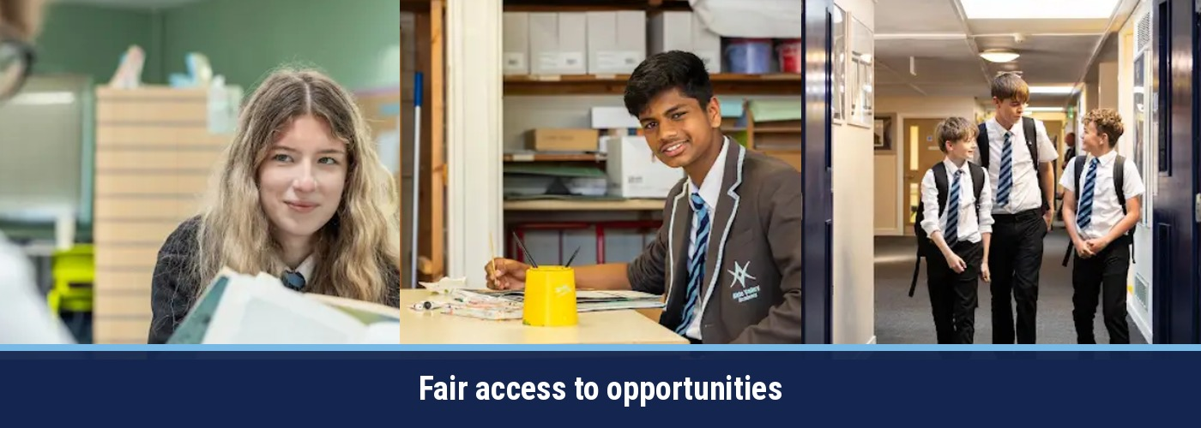

Spiritual, moral, social and cultural development, British Values and inclusion are not add-ons. They are deliberately planned through the taught curriculum, assemblies, relationships, leadership, enrichment and the way the academy supports individual students.

SMSC AND BRITISH VALUES
SPIRITUAL  Identity, beliefs, values and reflection. | MORAL  Ethical choices, consequences and responsibility. | SOCIAL  Relationships, teamwork and community participation. | CULTURAL  Diversity, inclusion and protected characteristics.
DEMOCRACY  Voice and participation | RULE OF LAW  Rights and responsibilities | INDIVIDUAL LIBERTY  Informed and safe choices | MUTUAL RESPECT & TOLERANCE  Respectful relationships and inclusion

INCLUSIVE ACCESS AND ADAPTIVE TEACHING
OUR PRINCIPLES  • High expectations for all  • Accessible curriculum design  • Reasonable adjustments  • Safeguarding-centred practice | ADAPTIVE STRATEGIES  • Pre-teaching vocabulary  • Visual and structured resources  • Chunking and sequencing  • Processing time and alternative recording | WHO WE CONSIDER  • Students with SEND  • Pupil Premium and vulnerable learners  • Young carers and looked-after children  • Students at risk of exploitation

ACCESS AND FINANCIAL SUPPORT: Families are encouraged to share accessibility needs early. Pupil Premium requests for a subsidy towards a paid trip are considered confidentially on a case-by-case basis using the form later in this document.

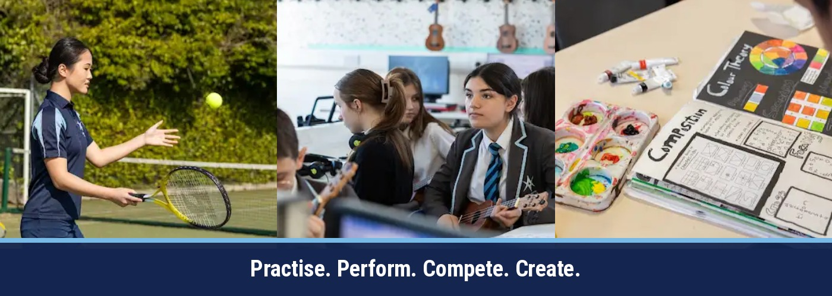

ENRICHMENT WITHIN ASPIRE
Experiences beyond the classroom

Enrichment is a core part of the whole-school Personal Development Offer. It connects classroom learning, PSHE and RSHE, careers and the assembly programme with experiences that build confidence, character, cultural capital and ambition. The following pages set out the planned 2026-2027 offer for students and families.

ASPIRE & ACHIEVE  Aim high, work hard and be the best we can be. | LEAD WITH KINDNESS  Act with respect and empathy and make a positive difference. | STRONGER TOGETHER  Support one another, celebrate difference and achieve more together.

OUR ENRICHMENT PROMISE
CURRICULUM-LED TRIPS  Visits and fieldwork that bring subjects to life and build cultural capital. | CLUBS & COMPETITIONS  Academic, creative, digital and sporting opportunities across the year.
LEADERSHIP & CAREERS  Ambassador roles, employer encounters, college visits and work experience. | ACCESS FOR ALL  Early notice, flexible payment plans and targeted support for eligible families.

A PLANNING GUIDE FOR FAMILIES
The academy will share confirmed trip letters, costs, consent deadlines and payment schedules as early as possible. Planned activities may change where providers, staffing, transport, weather, risk assessment or student take-up require it.

TRIPS AND EXPERIENCES AT A GLANCE
Key planned visits for 2026-2027 - more detail appears on the year-group pages

Trips widen horizons, deepen subject knowledge and create shared experiences that students remember. Paid, low-cost and free opportunities are highlighted below so families can plan ahead.

YEAR | TRIP / EXPERIENCE | PLANNED TIMING | COST
Y7 | Hampton Court Palace | Oct 2026 | FREE
Y7 | London history walk and Hadestown matinee | Oct 2026 | £25
Y7 | Geography rivers fieldwork | Jun 2027 | TBC
Y8 | Normandy, Battlefields Trip | Sep 2027 | £550
Y8 | The Curious Incident, Cambridge New Theatre | Feb 2027 | Tickets TBC
Y8 | Ipswich College and Suffolk Rural College | May 2027 | free
Y9 | Leiston cinema: The Impossible | Dec 2026 | £2.50
Y9 | Lille Christmas Market | Nov/Dec 2026 | £550
Y9-11 | Blood Brothers, Norwich Theatre Royal | 27 Mar 2027 | £27
Y10 | Lowestoft and Southwold GCSE geography fieldwork | Nov 2026 / Jun 2027 | free
Y10 | Work experience week | Jun 2027 | No trip charge
Y11 | Colchester Zoo art research visit | Sep 2026 | TBC
Y11 | Live Theatre Review visit | TBC | £20

START PLANNING EARLY
Where a cost is still to be confirmed, the academy will publish the total and an instalment plan as soon as provider bookings and transport are secure. All dates and costs are provisional until confirmed in a trip communication.

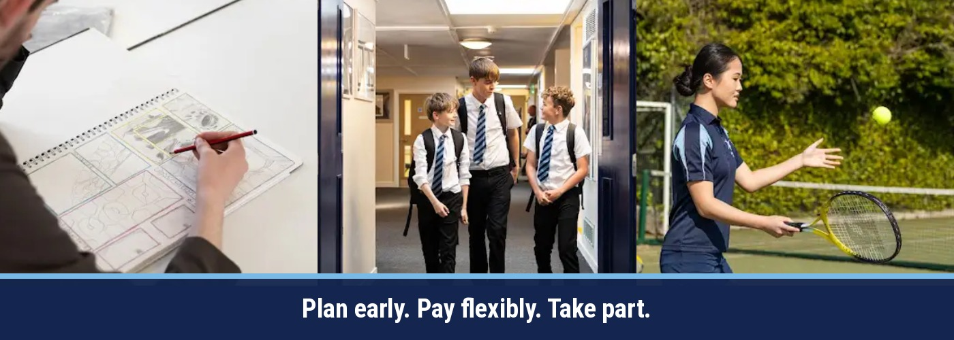

PAYMENT PLANS AND AFFORDABILITY
Giving families the longest practical time to plan and pay

Our aim is to open paid trips as early as provider arrangements allow, show the full expected cost clearly, and let families spread payments into manageable instalments. Families may pay more frequently, pay ahead, or clear the balance early.

TRIP COST | NOTICE / WINDOW | PAYMENT APPROACH | ILLUSTRATIVE EXAMPLE
Up to £30 | Aim for at least 3 months | 3-6 small payments | £25 = 5 x £5
£31-£100 | Aim for at least 5 months | 5-10 payments | £60 = 6 x £10
£101-£250 | Aim for at least 8 months | 8-12 payments | £120 = 8 x £15
Over £250 / residential | Aim for 10-12+ months | Monthly plan where possible | £240 = 12 x £20

OUR PAYMENT PRINCIPLES
• The total expected charge is stated at launch.  • Any provider deposit or cancellation terms are explained clearly.  • Higher-cost trips are offered with the longest realistic payment window. | • Late opportunities receive the longest window available.  • Optional extras are identified separately.  • Families facing difficulty are encouraged to contact the academy confidentially and early.
IMPORTANT
The examples above illustrate our intended approach rather than a fixed entitlement. Each trip plan depends on provider deadlines and booking conditions. The confirmed schedule in the trip communication will apply.

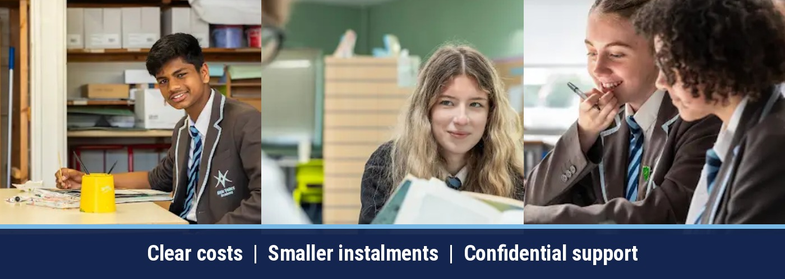

PUPIL PREMIUM TRIP SUPPORT
Requests are considered individually and confidentially

CASE-BY-CASE SUPPORT FOR PAID SCHOOL TRIPS
If your child qualifies for Pupil Premium funding and you would like the academy to consider a subsidy towards a paid school trip, please complete the request form below. Every request will be reviewed on a case-by-case basis. Eligibility does not automatically guarantee support or a particular level of subsidy.

HOW TO APPLY
1  CHECK  Confirm that your child qualifies for Pupil Premium funding and identify the paid trip. | 2  COMPLETE  Fill in the request form below, including the trip details and a brief explanation. | 3  EMAIL  Send the completed form to r.battle@aldevalley.suffol.sch.uk. The academy will reply confidentially.

PUPIL PREMIUM PAID TRIP SUBSIDY REQUEST FORM
Please complete all relevant sections
STUDENT FULL NAME  ________________________________________________________________________________ | YEAR GROUP AND TUTOR GROUP  ________________________________________________________________________________
PARENT / CARER FULL NAME  ________________________________________________________________________________ | CONTACT EMAIL OR TELEPHONE  ________________________________________________________________________________
PAID TRIP / VISIT REQUESTED  ________________________________________________________________________________ | TRIP DATE (IF KNOWN)  ________________________________________________________________________________
PUBLISHED TRIP COST  ________________________________________________________________________________ | SUBSIDY REQUESTED (AMOUNT OR PERCENTAGE)  The academy will determine the level of any support awarded.  ________________________________________________________________________________
BRIEF REASON FOR THE REQUEST
Please explain briefly how a subsidy would help your child take part. You do not need to include detailed or sensitive financial information.
____________________________________________________________________________________________________
____________________________________________________________________________________________________
DECLARATION
I confirm that the information provided is accurate and give permission for the academy to verify Pupil Premium eligibility. I understand that requests are considered case by case, support is not guaranteed, and normal trip places, consent, payment and cancellation deadlines still apply.
PARENT / CARER SIGNATURE  ________________________________________________________________________________ | DATE  ________________________________________________________________________________
EMAIL THE COMPLETED FORM TO: r.battle@aldevalley.suffol.sch.uk
Suggested email subject: Pupil Premium Trip Subsidy Request - [Student Name]

SUMMER ENRICHMENT PROGRAMME
A choice of memorable experiences beyond the usual curriculum

The Summer Enrichment Programme will be organised nearer the time and will form a visible part of the ASPIRE offer. Students will be invited to choose from a range of experiences designed to build confidence, wellbeing, resilience, teamwork and independence.

PLEASUREWOOD HILLS  A shared day of challenge, confidence and memorable experiences. | FOOTGOLF  An active, inclusive mix of football skills, strategy and teamwork.
CLIP 'N CLIMB  Personal challenge, problem-solving and resilience in a safe environment. | FELIXSTOWE BEACH  Coastal activities, wellbeing, games and time together outdoors.
FOREST SCHOOL DAYS  Practical outdoor learning, collaboration, creativity and independence. | HOW CHOICES WILL WORK  Students will be invited to rank preferences. Places depend on availability, staffing, weather, risk assessment and parental consent.

DETAILS WILL FOLLOW
Confirmed dates, costs, transport, clothing or equipment requirements, consent arrangements and payment plans will be shared as soon as providers are secured. Activities are subject to availability and may be adjusted.

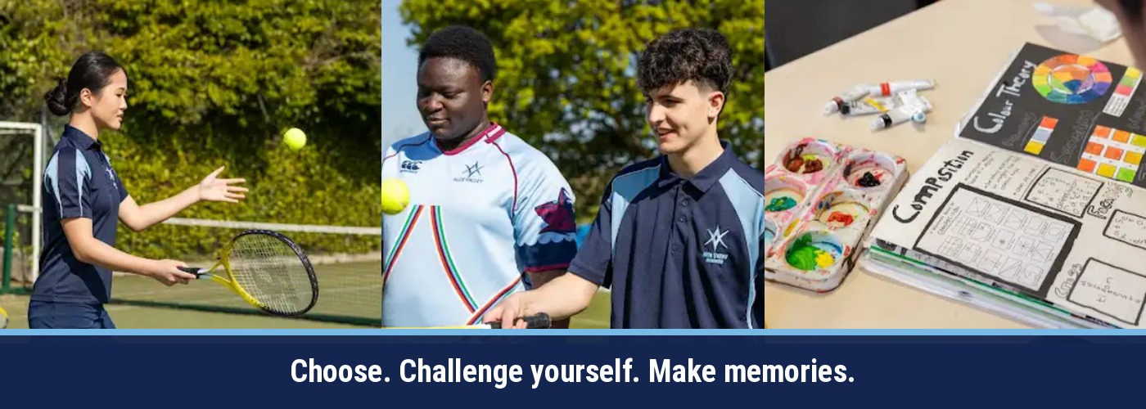

YEAR 7 ENRICHMENT JOURNEY
Belong, explore and build confidence

TRIPS & CURRICULUM EXPERIENCES  • London history walk and Hadestown matinee - October 2026 - £25.  • Geography rivers fieldwork - June 2027.  • Sax Arts Festival with a local actor/director - June.  • European Day of Languages activities - September 2026.  • Christmas Concert and school production opportunities. | CLUBS, COMPETITIONS & WIDER OPPORTUNITIES  • Creative Writing Club and half-termly Book Club.  • UKMT Junior Maths Challenge - 5 May 2027.  • Power Up STEM and Environmental Eco Club.  • Computer and Gaming Clubs, Bebras Challenge and coding.  • Band Club, KS3 Art Club, photography and DT workshop clubs.  • Extensive sports programme including netball, football, swimming, badminton, athletics, rounders, rugby, trampolining and gym use.  • PSHE enrichment, guest speakers, charity events, police and nurse drop-ins.

ASPIRE IMPACT: Students settle into academy life, build friendships, discover new interests and begin linking subject learning to the wider world.
Dates and activities are planned and may be refined during the year.
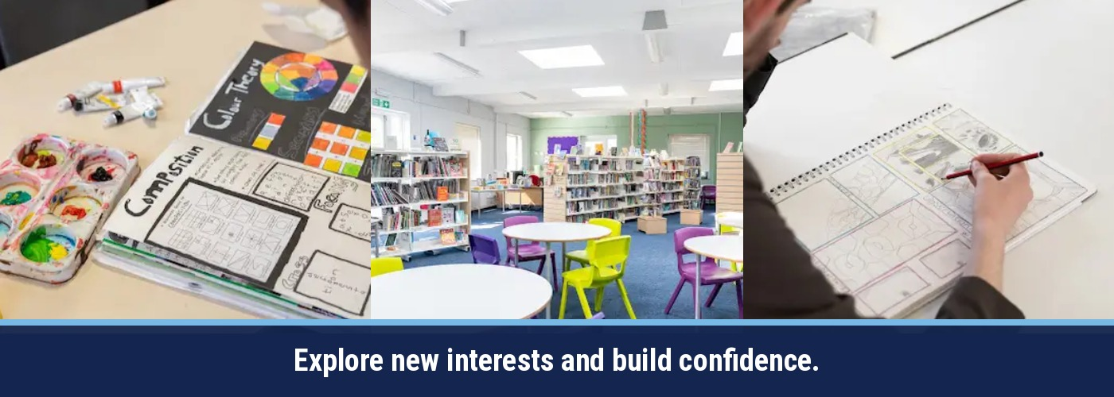

YEAR 8 ENRICHMENT JOURNEY
Broaden horizons and strengthen independence

TRIPS & CURRICULUM EXPERIENCES  • The Curious Incident of the Dog in the Night-Time, Cambridge - February 2027 - subject to ticket availability.  • Whole-year visit to Ipswich College and Suffolk Rural College - May 2027.  • Dora Love Holocaust memorial competition - April 2027.  • European Day of Languages - September 2026.  • Drama and music showcases - June/July 2027. | CLUBS, COMPETITIONS & WIDER OPPORTUNITIES  • Creative Writing Club and writing competitions.  • UK Maths Challenge - 5 May 2027.  • Power Up STEM and Environmental Eco Club.  • Computer and Gaming Clubs, Bebras, Gemini Student Certificate and iDEA Award.  • School production, band, Christmas concert and showcase.  • KS3 Art Club, local artists, exhibitions and Trust photography competition.  • Wool4School and V&A design initiatives.  • Sports including netball, basketball, rounders, athletics, football, swimming, badminton and rugby.

ASPIRE IMPACT: Students develop cultural understanding, curiosity, teamwork and the confidence to take on more ambitious experiences.
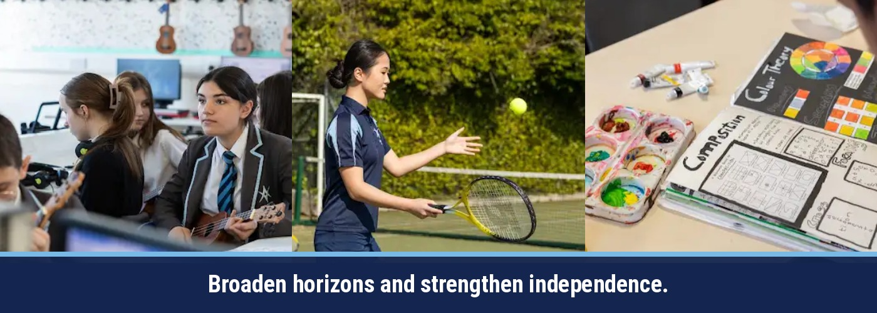

YEAR 9 ENRICHMENT JOURNEY
Make informed choices and take on new challenges

TRIPS & CURRICULUM EXPERIENCES  • Leiston cinema geography visit to The Impossible - December 2026 - £2.50.  • Lille Christmas Market - November/December 2026 - cost TBC.  - Normandy/ The Battlefields Trip- Sep 2027- £550  • Blood Brothers, Norwich Theatre Royal - 27 March 2027 - £27.  • INK scriptwriting workshop and festival experiences - free elements included.  • Suffolk New College visit - June 2027.  • Duke of Edinburgh Bronze applications - October 2026; training begins January. | CLUBS, COMPETITIONS & WIDER OPPORTUNITIES  • Creative Writing and Book Clubs; Saxmundham Arts Festival.  • Power Up STEM and Environmental Eco Club.  • European Day of Languages and Duolingo activities.  • Computer and Gaming Clubs; I Belong event at BT Park.  • School production, drama showcase, Christmas concert and after-school band.  • KS3 Art Club, local exhibitions and photography competition.  • Wool4School, Morgan Sindall links and DT competitions.  • Extensive sport including football, rugby, swimming, netball, tennis, athletics, trampolining and cross-country.

ASPIRE IMPACT: Students grow in resilience, independence and responsibility while exploring options, careers and leadership pathways.
Duke of Edinburgh participation involves additional training, expedition and section requirements.


YEAR 10 ENRICHMENT JOURNEY  Apply learning, build employability and prepare for success | 

TRIPS & CURRICULUM EXPERIENCES  • Sizewell B science visit - timing TBC.  • Lowestoft GCSE geography fieldwork - November 2026.  • Southwold GCSE geography fieldwork - June 2027.  • Lille Christmas Market - November/December 2026.  • Blood Brothers, Norwich Theatre Royal - 27 March 2027 - £27.  • Factory tour / Mini plant Oxford - timing TBC.  • Health and Social Care visit to a Saxmundham care home - December 2026.  • Work experience week - June 2027. | CLUBS, COMPETITIONS & WIDER OPPORTUNITIES  • Critical Understanding English and Creative Writing clubs.  • Success sessions in geography and history.  • Speaking intervention and Duolingo competitions.  • Computer and Gaming Clubs; Bebras and Gemini Student Certificate.  • Drama club, school production, INK and physical theatre workshops.  • KS4 band and Suffolk New College taster sessions.  • KS4 art studio, external exhibitions and national competitions.  • KS4 DT club, Wool4School and industry-linked challenges.  • Sports programme, careers assemblies, apprenticeship information and mock interviews.

ASPIRE IMPACT: Students connect curriculum learning to workplaces, public performance, fieldwork and real responsibilities, supporting GCSE progress and future choices.
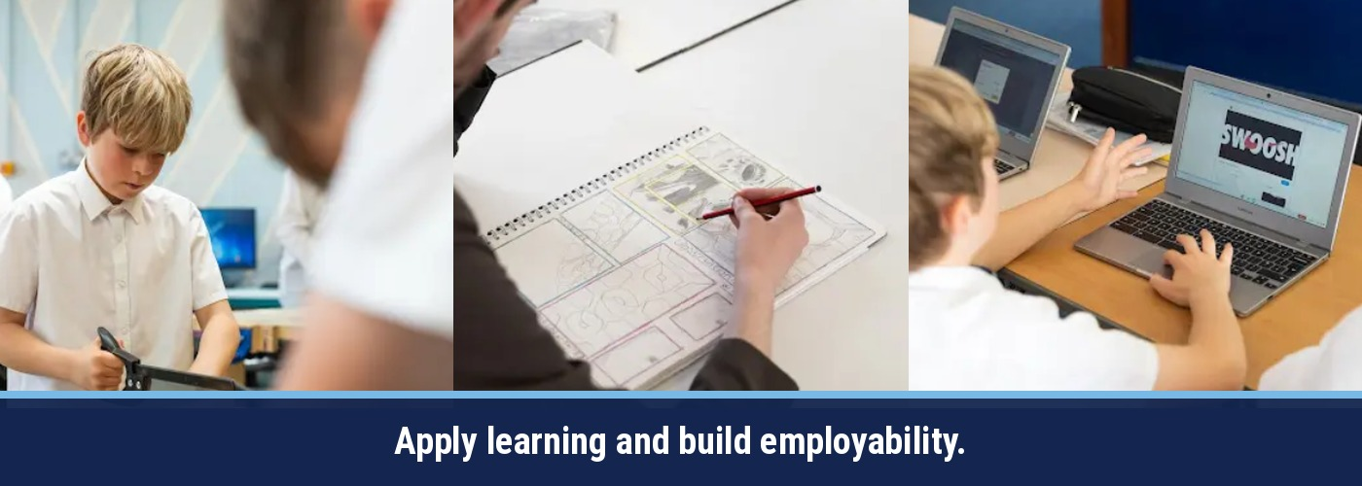

YEAR 11 ENRICHMENT JOURNEY  Celebrate achievement and move confidently to the next stage | 

TRIPS & CURRICULUM EXPERIENCES  • Theatre visits when GCSE literature texts are performed - as available.  • Christmas Market trip - timing and cost TBC.  • Blood Brothers, Norwich Theatre Royal - 27 March 2027 - £27.  • Live Theatre Review visit - £20 - timing TBC.  • Colchester Zoo art research visit - September 2026.  • Health and Social Care visit to a Saxmundham care home.  • Careers Fair at Trinity Park - November 2026. | CLUBS, COMPETITIONS & WIDER OPPORTUNITIES  • KS4 Book Club, Creative Writing and Critical Thinking English.  • European Day of Languages and fortnightly MFL revision.  • Computer Club; Bebras, coding and GCHQ Christmas Card Challenge.  • Drama club, school production and in-school workshops.  • KS4 band supporting the school pantomime and productions.  • Open art studio, external GCSE exhibition and photography competitions.  • Sports opportunities throughout the week.  • Post-16 presentations, apprenticeship and university speakers, college support and careers guidance.

ASPIRE IMPACT: Students consolidate subject knowledge, celebrate their contributions and receive focused support for examinations, applications and post-16 transition.
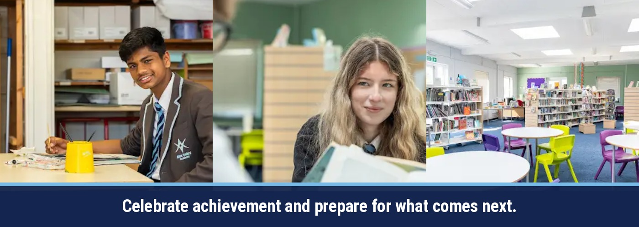

CLUBS, SPORT AND CREATIVITY  A rich weekly offer that helps every student find a place to belong | 

Across the academy, lunchtime and after-school opportunities enable students to practise, perform, compete, create, lead and contribute. The live timetable may change by term, year group, staffing and season.

SPORT & WELLBEING  Netball, football, swimming, badminton, athletics, rounders, rugby, tennis, trampolining, cross-country, basketball, cricket and gym access, depending on year group and term. | CREATIVE ARTS  School productions, drama clubs and showcases, bands, Christmas concerts, art clubs, exhibitions, photography competitions and set design.
ACADEMIC ENRICHMENT  Creative writing, book clubs, UKMT maths challenges, Power Up STEM, eco club, Bebras coding, computer and gaming clubs, Duolingo competitions. | DESIGN & INNOVATION  DT workshops, Wool4School, V&A initiatives, product design challenges, industry visits and practical problem-solving.
COMMUNITY & PERSONAL DEVELOPMENT  Charity events, guest speakers, police and nurse drop-ins, theatre workshops, PSHE enrichment and student-led events. | CELEBRATION & REWARD  Merit points, praise, awards, postcards home and celebration events that recognise effort, progress, character and contribution.
CLUB TIMETABLES
The confirmed After-School PE Clubs programme is shown on the next page. The all-clubs timetable is included immediately after the PE clubs page. Students should check tutor notices, subject communications and PE information for the latest details.

AFTER-SCHOOL PE CLUBS
Confirmed weekly sports programme for 2026-2027

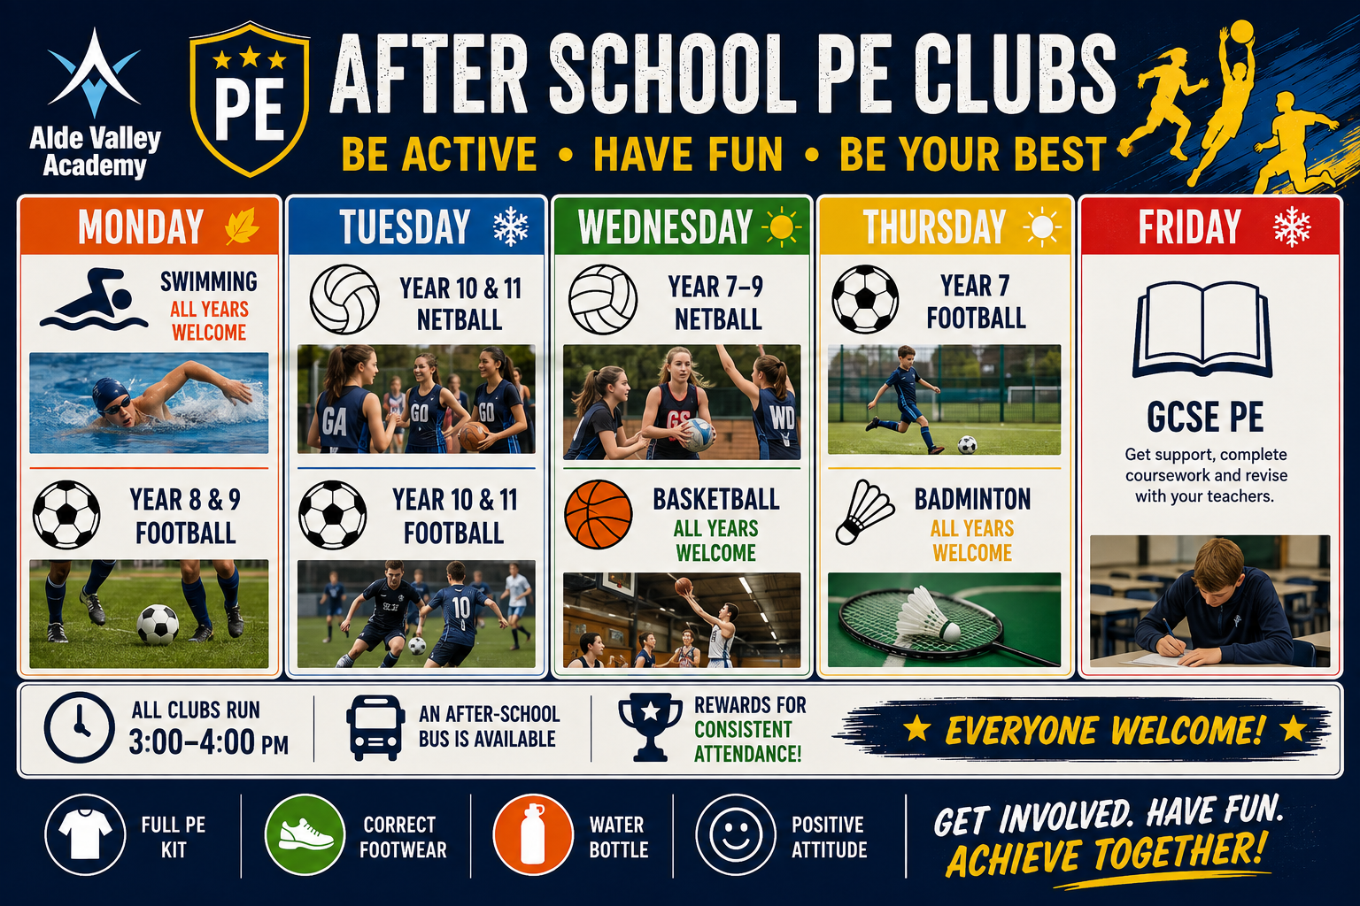
Explore more: the full before-school, lunchtime and after-school clubs timetable is on the next page. Check academy notices for updates.

WEEKLY CLUBS TIMETABLE
Autumn term 2026 | Before school, lunchtime and after school
FIND YOUR THING • MAKE FRIENDS • TRY SOMETHING NEW
There is something for everyone. Pick a club, give it a try and speak to the member of staff running it if you need more information.

DAY | BEFORE SCHOOL | LUNCHTIME | AFTER SCHOOL
MONDAY | — | Creative Writing Club  All year groups welcome | Swimming — all years  Year 8 & 9 football
TUESDAY | Choir | Gaming Club, IT1  Years 7 & 8 | Year 10 & 11 netball  Year 10 & 11 football  Alford Studio (Art Club) — all years
WEDNESDAY | — | DofE support sessions | Year 7–9 netball  Basketball — all years  Drama Club / show rehearsals  Maths homework club (IT2)
THURSDAY | — | — | Year 7 football  Badminton — all years  Computer Club — run by LongShop
FRIDAY | — | Gaming Club, IT1 — Years 9–11  Art 4 Wellbeing — all year groups | Show rehearsals (once begun)  GCSE PE
ALSO RUNNING | KS4 Book Club — half-termly
No breaktime clubs are listed in the current timetable. PE clubs run 3:00–4:00pm and an after-school bus is available. Other club times and arrangements should be checked with the club lead.

STAY CONNECTED WITH ALDE VALLEY  Scan for the academy website and the latest school information.  For the latest changes to clubs, please check school communications. | 

LEADERSHIP, CAREERS AND BRIGHT FUTURES  Preparing students for life beyond school | 

ASPIRE helps students understand themselves, contribute to their community and make informed choices. Careers education is embedded through tutor time, lessons, assemblies, employer encounters, college links and individual guidance.

YEAR 7-8 | EXPLORE | Tutor activities, curriculum links, college awareness and encounters that build curiosity about future pathways.
YEAR 9 | DISCOVER | Suffolk New College visit, option choices, Duke of Edinburgh and growing leadership opportunities.
YEAR 10 | EXPERIENCE | Mock interviews, employer engagement, apprenticeship information and a dedicated work experience week.
YEAR 11 | PROGRESS | Post-16 presentations, careers fair, college and apprenticeship support, applications and destination planning.
LEADERSHIP OPPORTUNITIES
• Subject Ambassadors and event leaders.  • Sports Leaders and team responsibilities.  • Peer mentoring and support roles. | • School Council and student voice.  • House events and celebration leadership.  • Volunteering and Duke of Edinburgh.
THE ASPIRE OUTCOME
Responsible, respectful and aspirational young people who understand pathways, communicate with confidence and are ready to contribute positively.

PRACTICAL INFORMATION FOR FAMILIES
Consent, communication, accessibility and keeping plans up to date

How will we hear about a trip?  A trip letter or digital communication will explain the purpose, date, cost, consent arrangements, payment schedule and deadline. | Are dates and costs guaranteed?  This prospectus is a planning guide. Provider availability, staffing, transport, risk assessment and sufficient take-up may lead to changes. The latest trip communication takes precedence.
How do payment plans work?  Families can make small payments through the school payment system. Where providers allow, higher-cost trips will open many months in advance. | What happens if payment is difficult?  Contact the academy confidentially as early as possible. If your child qualifies for Pupil Premium funding, you may request a subsidy for a paid trip using the form in this prospectus. Requests are considered case by case and should be emailed to r.battle@aldevalley.suffol.sch.uk.
What about medical or accessibility needs?  Share relevant information early so reasonable planning can take place. Individual risk assessments or support arrangements may be required. | How are places allocated?  The trip communication will explain any capacity limit or selection process. A place is confirmed only when the school states that it is confirmed.
KEEP THIS PROSPECTUS AS A GUIDE
The most recent academy communication always takes priority for confirmed dates, costs, payment deadlines, medical forms, kit lists, collection times and cancellation information.

IMPACT, EVIDENCE AND CONTINUOUS IMPROVEMENT
How the academy knows the offer is making a difference

The offer is intentionally planned, sequenced and evaluated. Leaders use curriculum evidence, participation information and student outcomes to identify strengths, respond to emerging needs and refine provision throughout the year.

EVIDENCE SOURCES  • Curriculum plans and lesson resources  • Student work and assessment  • Pupil voice and student leadership  • Careers records and destination data | IMPACT INDICATORS  • Attendance and behaviour patterns  • Safeguarding themes and misconceptions  • Participation in clubs, trips and leadership  • Confidence, readiness and successful transitions | QUALITY ASSURANCE  • Curriculum and resource review  • Learning walks and staff collaboration  • SEND and accessibility checks  • Annual evaluation and responsive refinement

THE REVIEW CYCLE
1  PLAN  Need, sequence and intended outcome | 2  DELIVER  Teach, model and provide experience | 3  LISTEN  Pupil voice, staff insight and safeguarding | 4  EVALUATE  Assessment, participation and destinations | 5  REFINE  Adapt curriculum, support and opportunities

OUR KEY QUESTION
Can students explain how the ASPIRE values shape their decisions, relationships, contribution and next steps?
When the answer is yes - and students can demonstrate it in action - personal development is having impact.

